Goal: Reproduce 2 parameter bifurcation plot for NNF 2M8 model

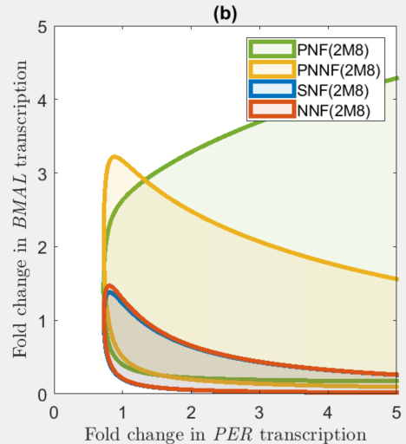

###### Main loop ###### NNF 2M8

dM/dt = phi*EBox_RL - M

phi = FCRTR

dP0/dt = M - P0

dP1/dt = P0-P1

dP2/dt = P1-P2

dP3/dt = P2-P3

dP4/dt = P3-P4

dP5/dt = P4-P5

# BPM degradation

dP/dt = P5 - beta*Km*P/(Km+P)

# NNF model

dAt/dt = delta * (AMAX/(1+V) - At)

dV/dt = delta * (VMAX*EBox_RL - V)

At(0) = 1

V(0) = 1

AMAX = FCATR

A_free(P,A,Kd)=0.5*(A-P-Kd+sqrt(((A-P-Kd)^2)+4*Kd*A))

# Rate Law 2

EBox_RL = A_free(P,At,Kd)/(A_free(P,At,Kd)+Ka)

param beta=60, Km=0.01

param Kd=0.1, delta=0.2, VMAX=1

param Ka=0.01

###### Fold change parameters ######

# FCATR = "fold change in activator (BMAL) transcription"

# FCRTR = "fold change in repressor (PER) transcription"

param FCRTR=1, FCATR=1

done

Test: Vmax = 1,

|  |  |  |  |
| --- | --- | --- | --- |
| Test id | FCRTR(Per) | FCATR(Bmal) | XY |
| 1 | 1 | 1 | Non-osci |
| 2 | 2 | 0.5 | Non-osci |
| 3 | 4 | 0.2 | Non-osci |

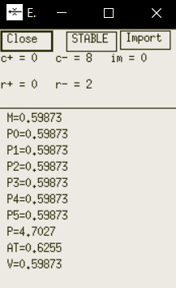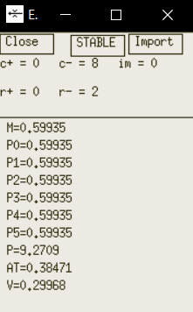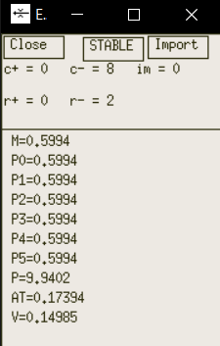

case 1 case 2 case 3

1 parameter bifurcation plot with respect to FCRTR

